Desktop Unity Net.Rumble Demo Game with Steamworks.NET (base Steam variant)

*\* This sample has been developed with Unity 2020.3.24f1 and the Steamworks on Windows 10.*

Description

This is a simple multiplayer game. It is expected that developers should be familiar with the basics of using Steamworks SDK and a popular Unity package Steamworks.NET, creating, configuring and developing games for Steam and uploading them to Steam Storefront with a Steam developer account, before building this sample game. They also need to create a Steam game for this project with their Steam developer account and know its AppId. This sample app is intended to demonstrate how developers can use the Steamworks API together to perform the following functions:

* Log in to the Steam server.
* Get the avatar, username, and user ID of the Steam login user.
* Find game lobbies, join game lobby, create game lobby, customize lobby attributes, and game matchmaking.
* Look up the Steam friends list and invite friends to join the game lobby.
* Accept a Steam friend invitation when not running the game, run the game, and join the lobby.
* After joining the lobby, display other Steam player avatars, player names, other player information, update player information, synchronize information of players in the lobby, and change ship color, ship type.
* After joining the lobby, start a multiplayer game, and multiplayer voice chat.
* Get Steam player inventory as well as update player inventory.
* Get Steam player achievements, scores, and display leaderboards.
* Create new leaderboards, upload game scores, and upload statistical information.

# Building the Sample

* This example depends on Steamworks.NET Unity package and Steamworks SDK (upload tools only). Developers will need to download Steamworks.NET Unity package and import it into Unity to satisfy the SDK dependencies required by the example.
* Steamworks.NET Unity package download link：[Releases · rlabrecque/Steamworks.NET (github.com)](https://github.com/rlabrecque/Steamworks.NET/releases)
* In opened Unity project, navigate to Assets/Import Package/Custom Package in the main menu to import the Steamworks.NET Unity package.
* To use the Steamworks.NET, make sure that a macro symbol "STEAMWORKS_NET" is defined in Player à Other Settings à Script Compilation à Scripting Define Symbols fields of Project Settings screen.
* The example has only one "SampleScene.unity" scene and the path is: "Assets/Sample/Scenes".
* Upon opening the scene, you may be prompted to import TextMesh Pro resources in a popup window, please import both essentials and extras:  
  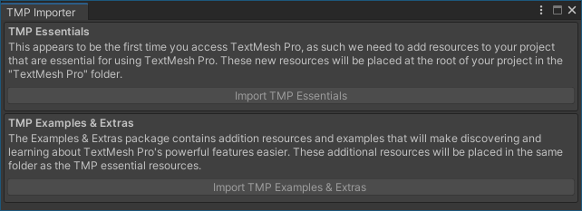
* Create a new empty object in SampleScene, name it SteamManager, and add the SteamManager.cs script to it. The path to SteamManager.cs is: "Assets\ Scripts \ Steamworks.NET \ SteamManager.cs"
* The SteamManager.cs originates from: [rlabrecque/Steamworks.NET-SteamManager: This is a basic Unity script which controls Steamworks.NET (github.com)](https://github.com/rlabrecque/Steamworks.NET-SteamManager)
* Download and unzip the Steamworks SDK with upload tools before building, download link：<https://partner.steamgames.com/downloads/steamworks_sdk.zip>

# Packaging Tutorial：

1. Find "simple_app_build.vdf" in the Steamworks SDK folder: "\SDK \tools\ContentBuilder\scripts" and open it in a text editor

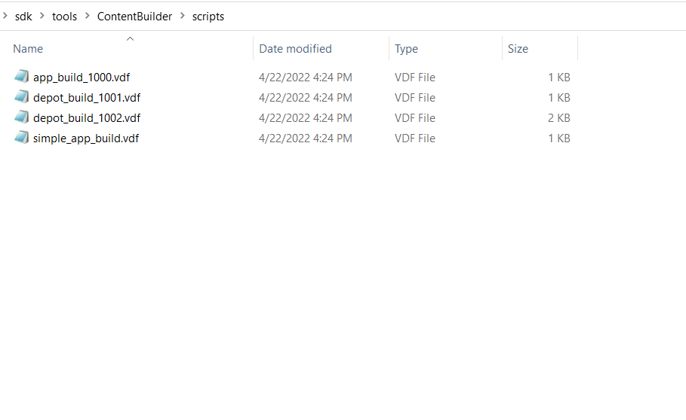

1. Enter your Steam game AppID and your DepotID, save and close.

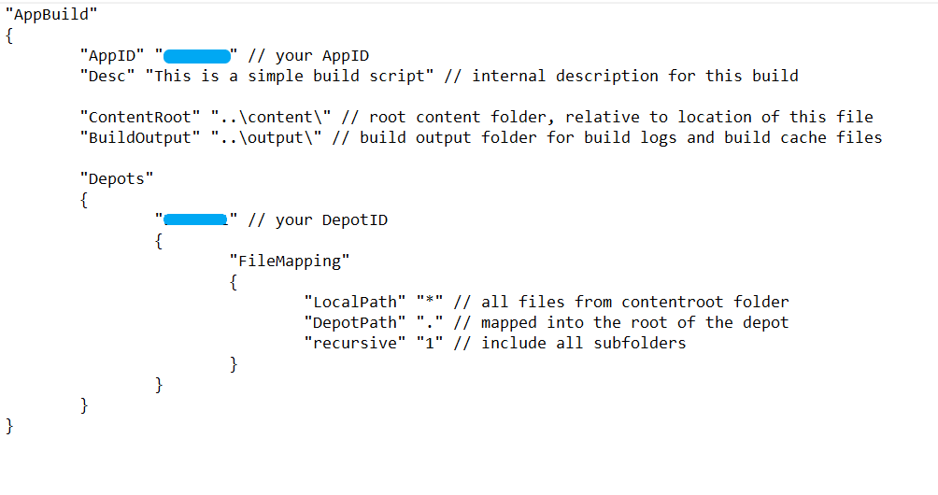

1. Modify "\SDK\tools\ContentBuilder\run_build.bat" by adding the required Steam account login information as shown in the following figure, save and close:

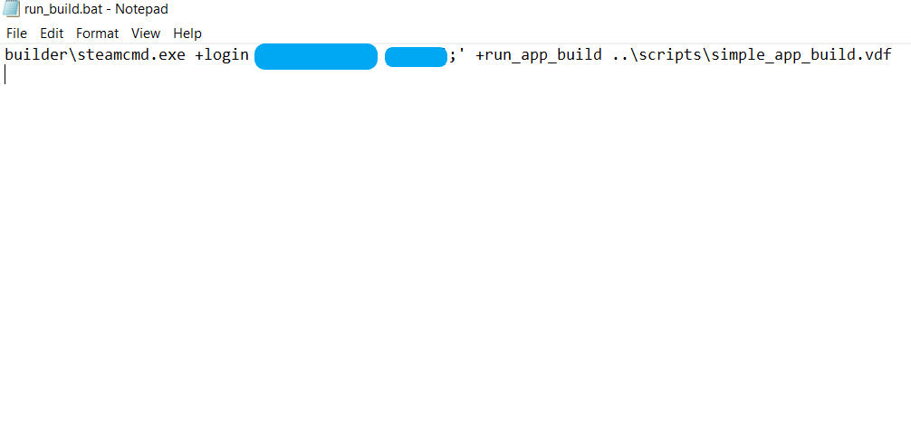

1. Use an editor to open the SteamManager.cs file, file path is “\Assets\Scripts\Steamworks.NET\SteamManager.cs” , find the line that defines the AppID contant (AppId = ) and set its value to your Steam game's AppId, as shown in the following figure:

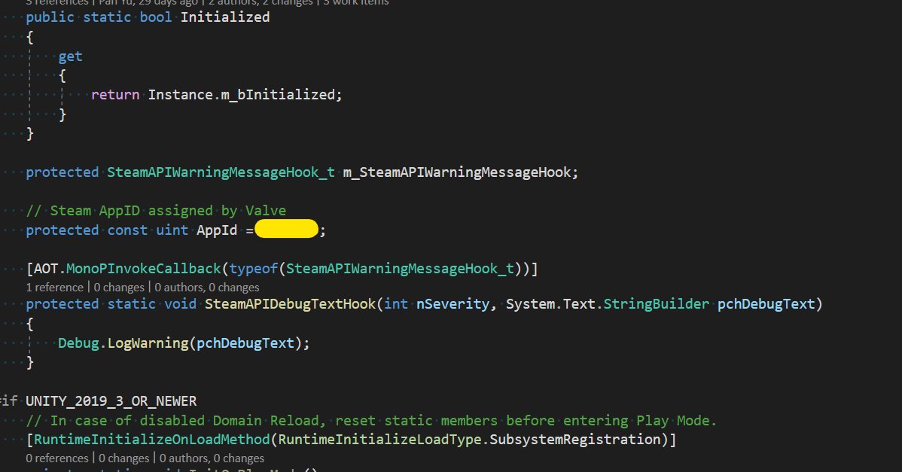

1. Set Product Name to be the same as the game name set on STEAMWORKS dashboard (otherwise Steam will not be able to launch the game)：

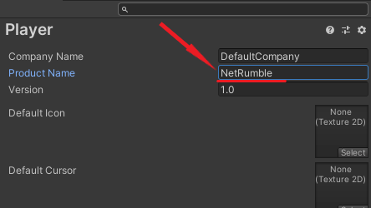

1. Add SampleScene to Scenes in Unity Build Settings.

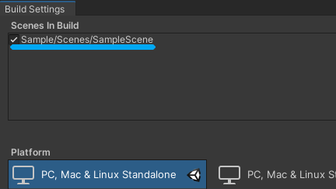

1. Click the "Build" button to select the build path and set the build path to "\SDK\Tools\ContentBuilder\Content\", click select Folder button to start building, and the build Package Folder will be opened automatically after the build is completed. The folder structure is shown in Figure 2 below:

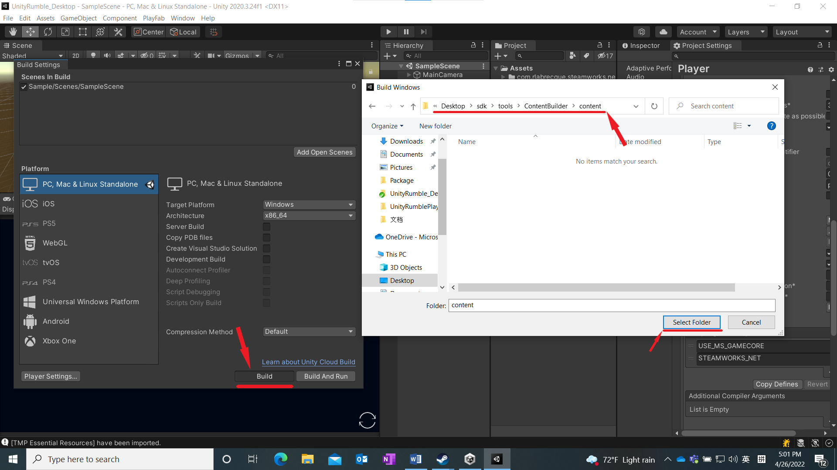

（Figure 1）

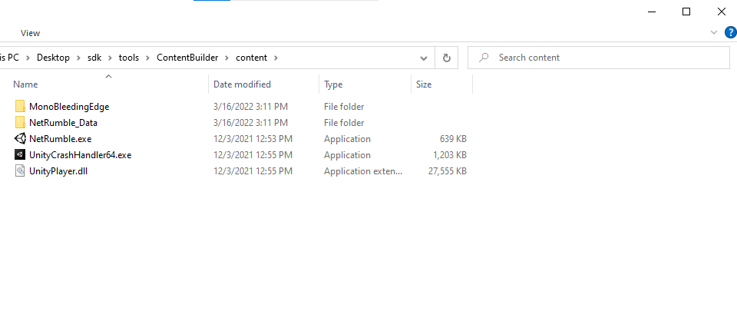

（Figure 2）

1. Run the run_build.bat

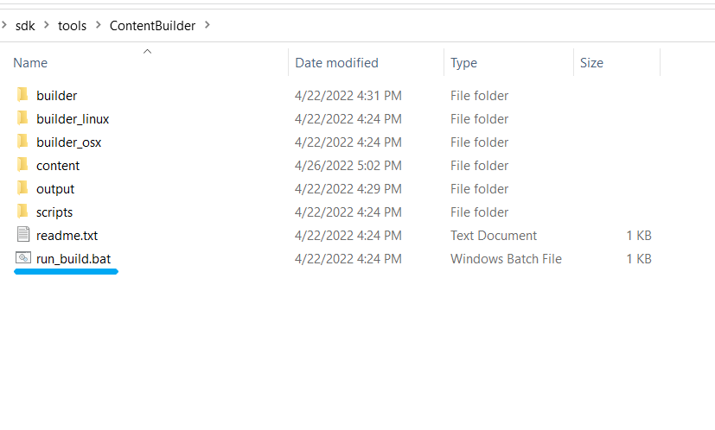

1. After the package is uploaded, view the Build ID

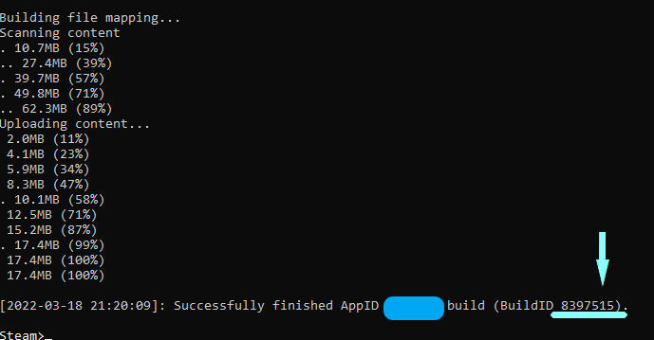

1. Open the Steam Dashboard, log in with Steam Account, and click All Applications.

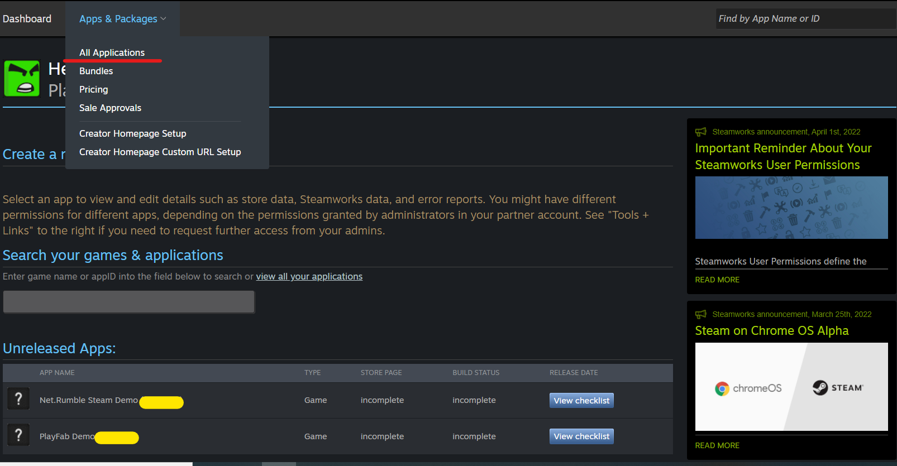

1. Find your project, click Steamworks Admin.

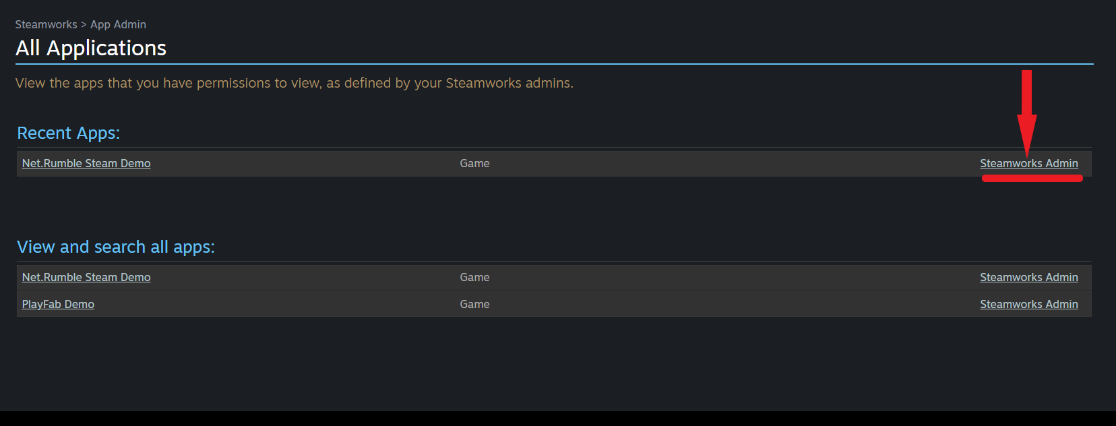

1. Click SteamPipe and click Builds.

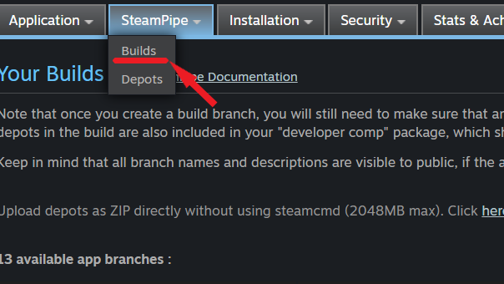

1. Click the "Create new app branch", enter the branch name to input box, and click OK.

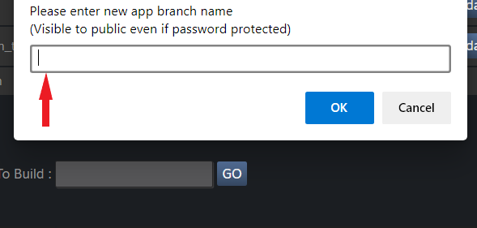

1. Enter the password in the Password input box, enter the description in the Description input box, and click the Update button.

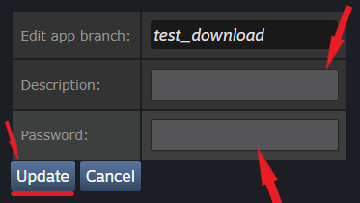

1. The red box is a right build, red line is build id. Find the right build in the list.

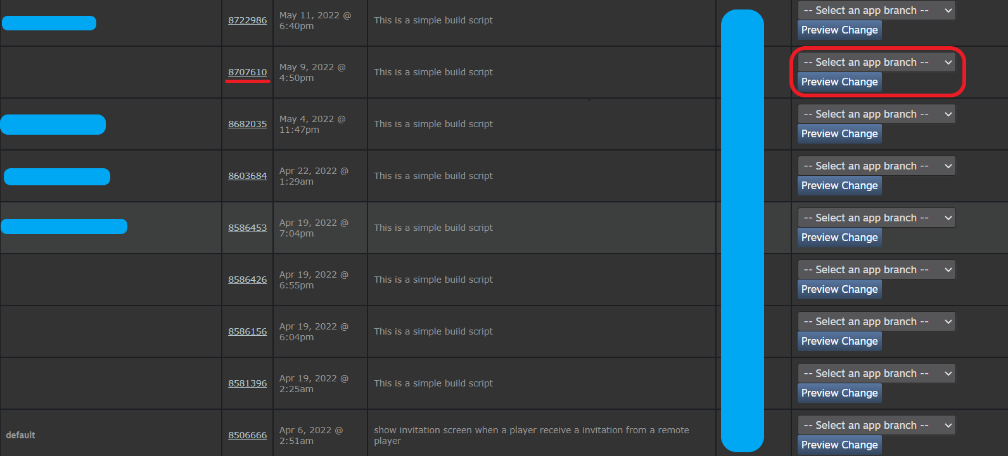

1. Update the newly generated build version to the created branch. Select the branch and click it.

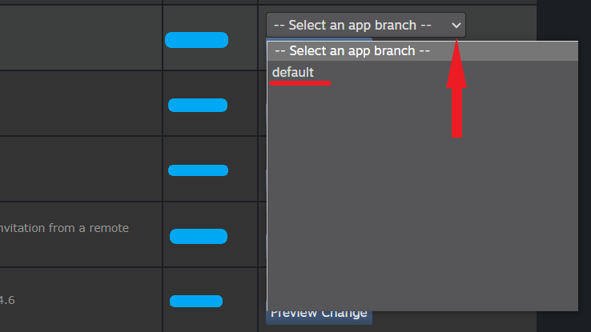

1. Click the Set Build Live Now button to update the build version.

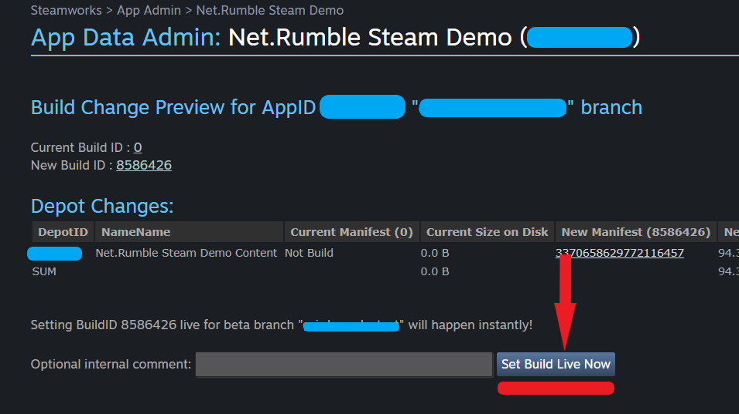

1. Open Steam, click Library, right-click the test game. Click the Properties button to jump to the properties interface

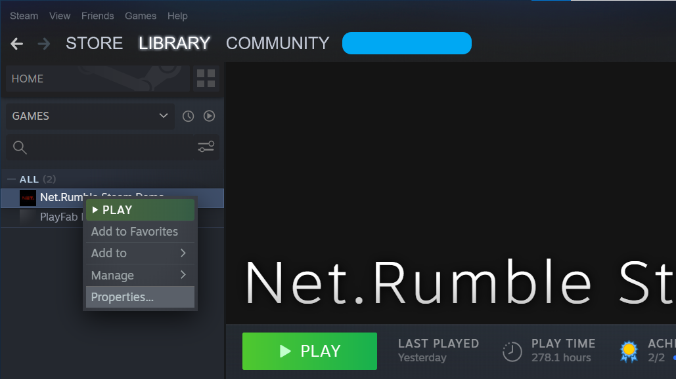

1. Click BETAS to open BETAS screen. Enter the beta access code to unlock private beta and click the Check Code button.

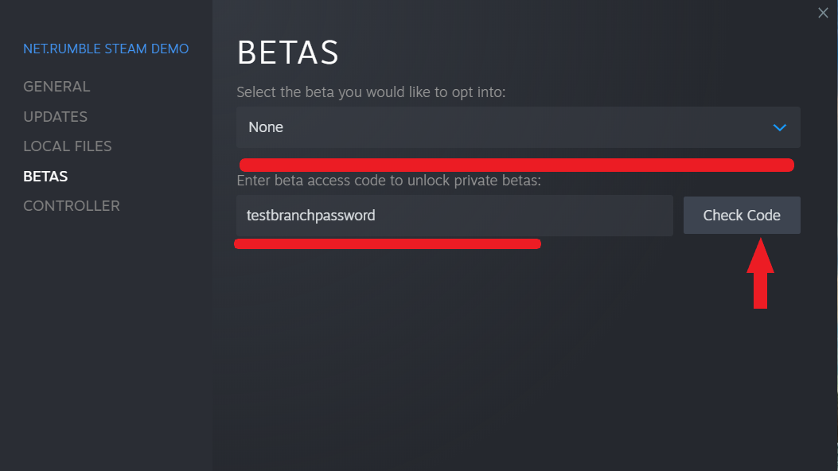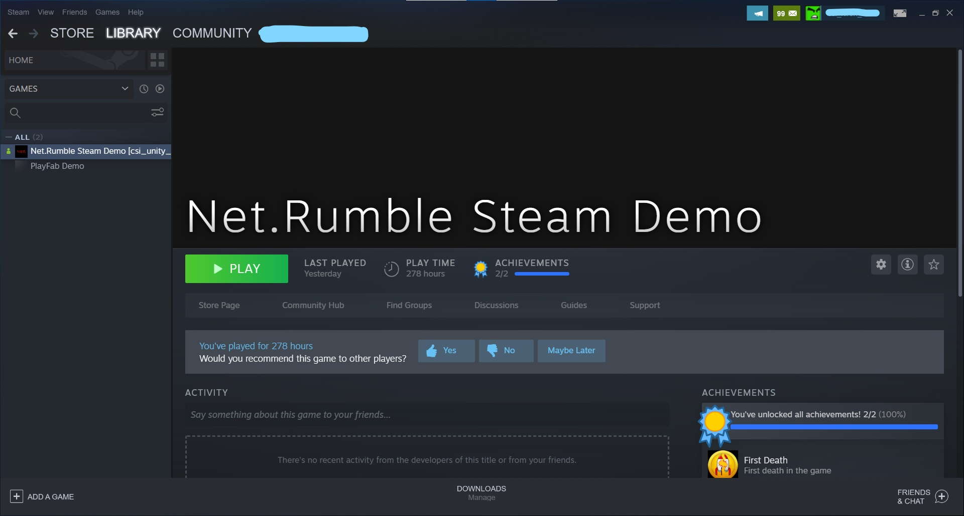

**Steam will automatically update apps downloaded from the beta branch.**

# Running the sample

After the app has been successfully built and installed on a Windows 10 PC, there will be an app icon called "Net. Rumble Steam Demo" on the desktop. Double click the application icon to launch the game.



# Sample Start Screen

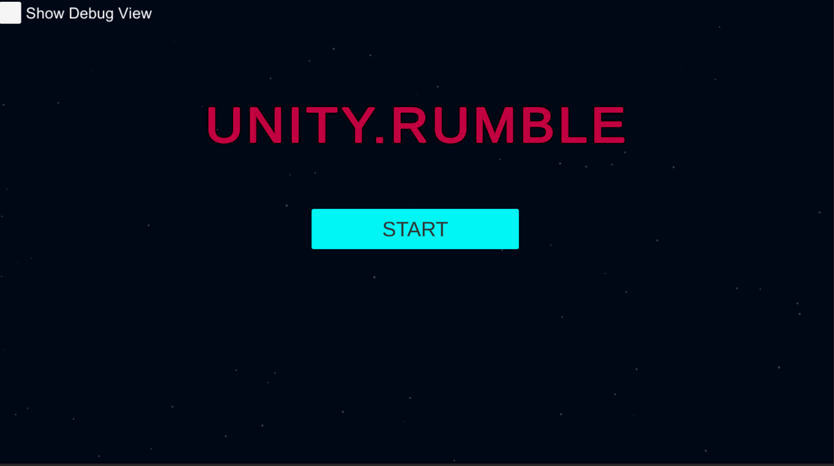

The screenshot shows the first interface when the sample is launched. Click the "Start" button to log into the Steam server. If any of the login steps fail, a failure message is displayed at the bottom of the screen and the screen remains on the start screen.

Common failure scenarios may be that users are unable to access their current Steam account, their Internet connection is disconnected, or Steam is experiencing some form of service disruption.

# Sample Main Menu Screen

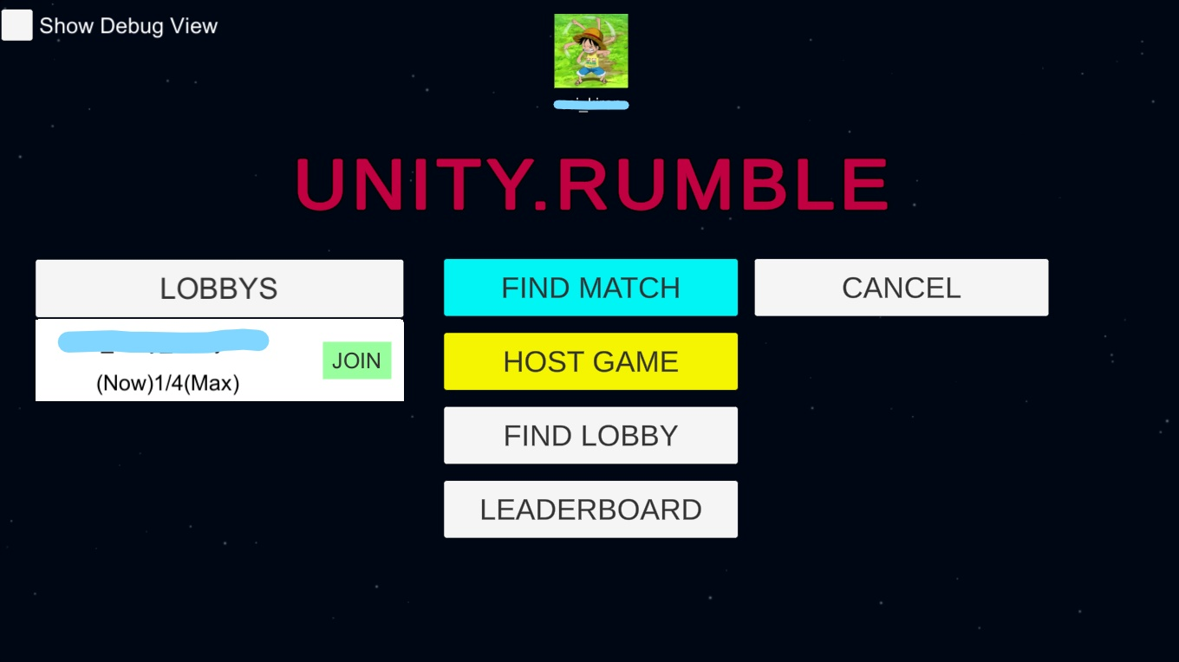

When the user successfully logs into Steam, the Main Menu screen for the sample is displayed. The four main features provided are:

1. Click the "FindMatch" button to start matching the game.

2. Click the "Host Game" button to create a game lobby which will make the lobby available for other players to find and join it.

3. Click the "Find LOBBY" button to display all the available game lobbies. After a lobby has been found all available lobbies will be displayed under "LOBBIES"

4. Click the "LEADERBOARD" button to open the Leaderboard Screen.

If any of the above functions fail, an error message will be displayed at the bottom of the screen, and the user is left on the Main Menu screen.

# Find Match Screen

When the "FIND MATCH" button is clicked, the player starts matching the game, as shown below, with the message that the player is matching at the bottom of the screen

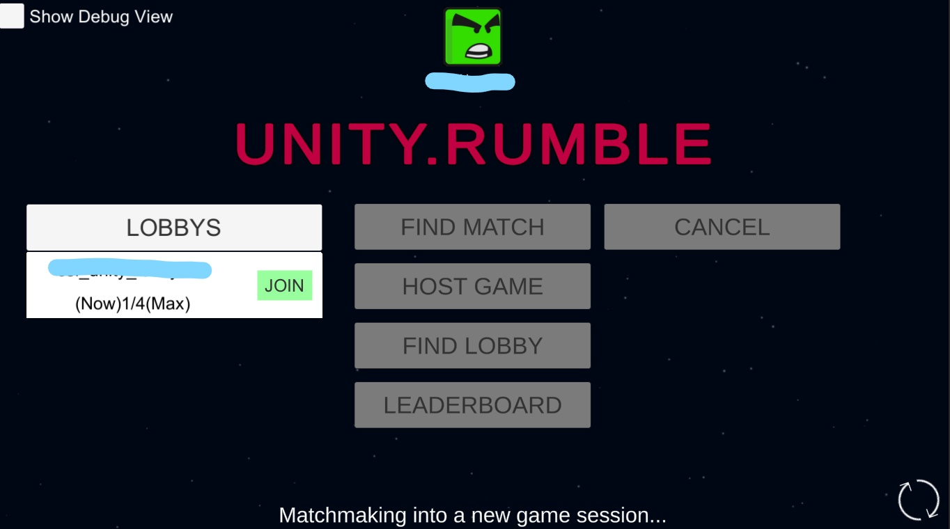

When the player successfully matches a game, the lobby screen opens, as shown below:

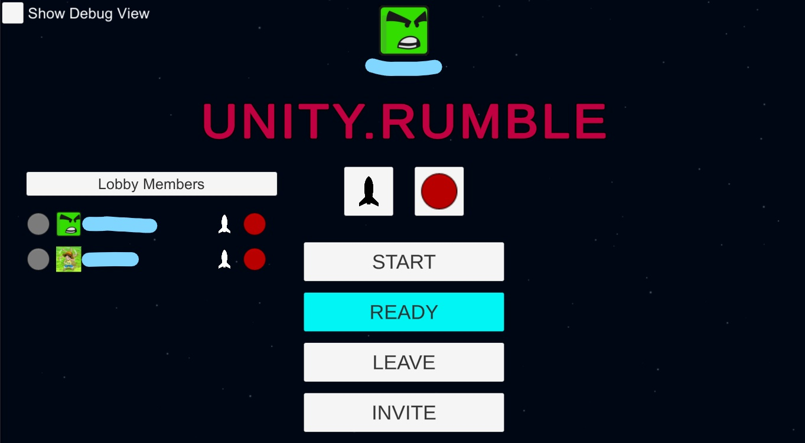

If no player is currently matching, the system automatically creates a Lobby for the player and displays the Lobby screen, as shown below:

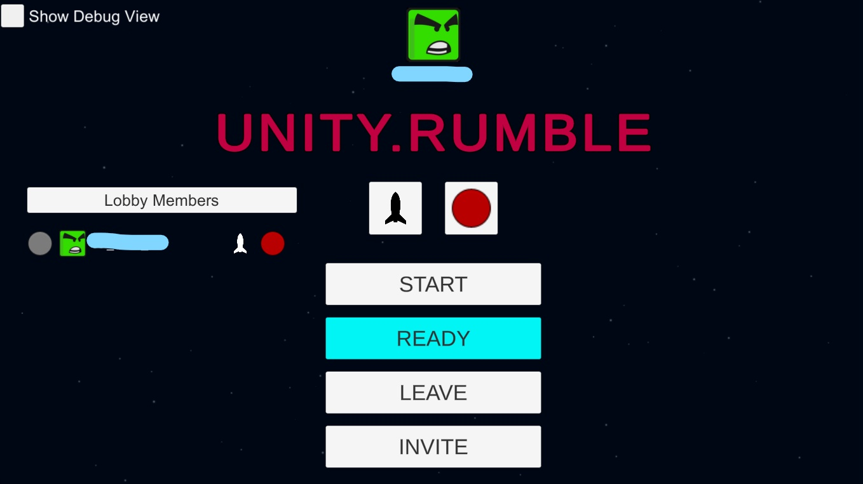

# The Game Lobby Screen

Click the "HOST GAME" button and Steam will create a Lobby for the player, which can be found by other players. Once the lobby is created, the GAME Lobby Screen will open, as shown below:



# Host and Invite Friend into a Lobby

The player creates the game Lobby on the "Host Game" button on the "Main Menu" screen, and the "Invite" button appears on the Game Lobby screen. Clicking the "Invite" button will open the Steam friends screen, where users can select friends to invite, as shown below:

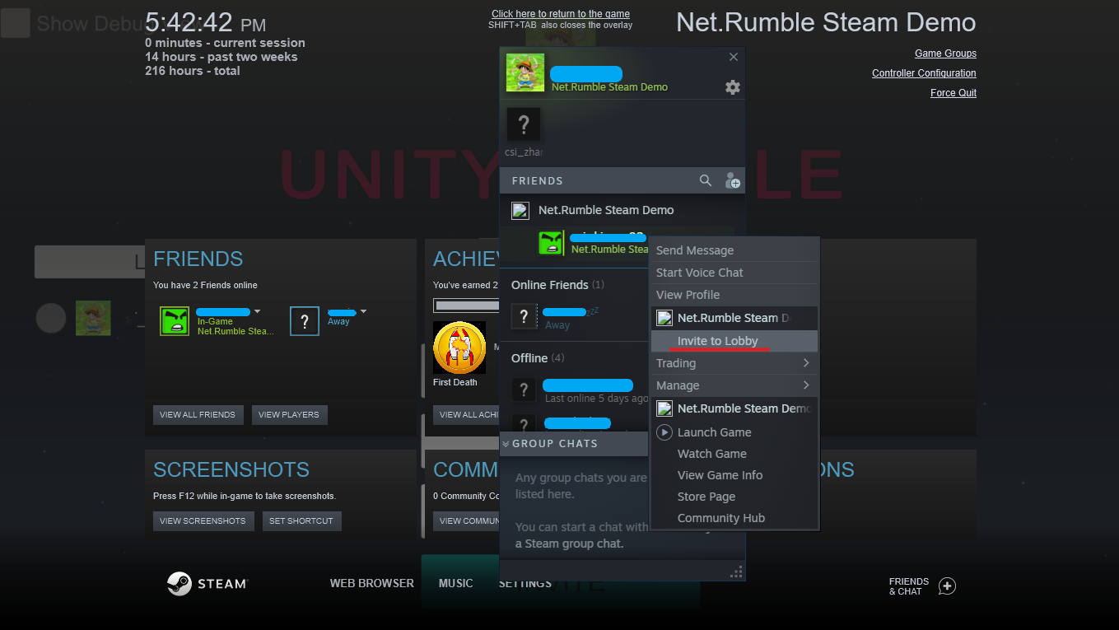

In Steam, if the invitation is not cancelled, the recipient will receive a notification that they have been invited to play Unity Rumble at which time they can either accept or decline the invitation. If the invitation is accepted and the Steam application is not running, the game will automatically start and join the lobby they were invited to. If the Steam application is already running, the player will automatically be invited to the lobby and the game screen will move to the game lobby. To start the game, click the “Play Game” button to accept the invitation, as shown below (There is no game icon in the invite screen because the project is not published):

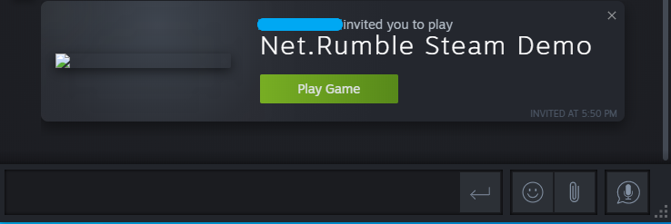

# The Ship Style and Color

Lobby members can change the style and color of their ships by clicking the "Ship" button or the “Color” button.

Ship Button： 

Color Button：

This example has four different ship styles and six different ship colors. The following picture shows the interface after clicking the ship button and the color button:

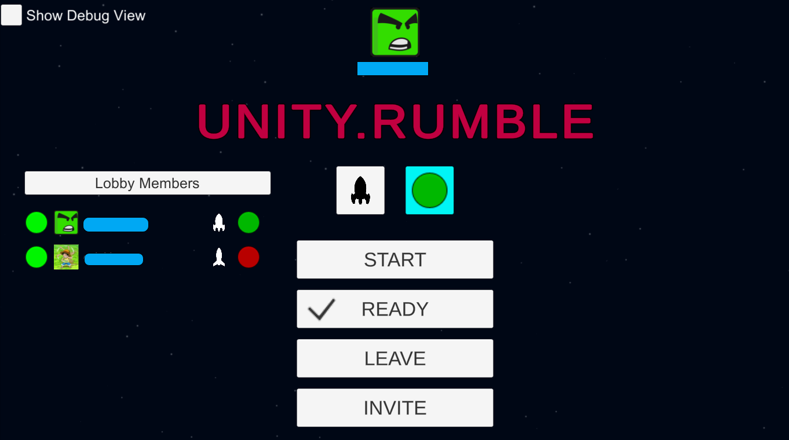

# The Lobby All Ready

When the members of the Lobby are ready to begin playing, they can change their state of ready by clicking the "Ready" button will synchronize the state with other members of the Lobby. When all players are ready, the player who created the Lobby can click the "Start" button to start the game and notify all members of the lobby that the game is beginning. All members of the lobby will see a countdown at the bottom of the screen indicating that the game is about to begin. The ready status is displayed before each username. Gray indicates that the user is not ready, and green indicates that the user is ready.

The following picture shows all users ready to display:



The picture below shows the countdown to starting the game：

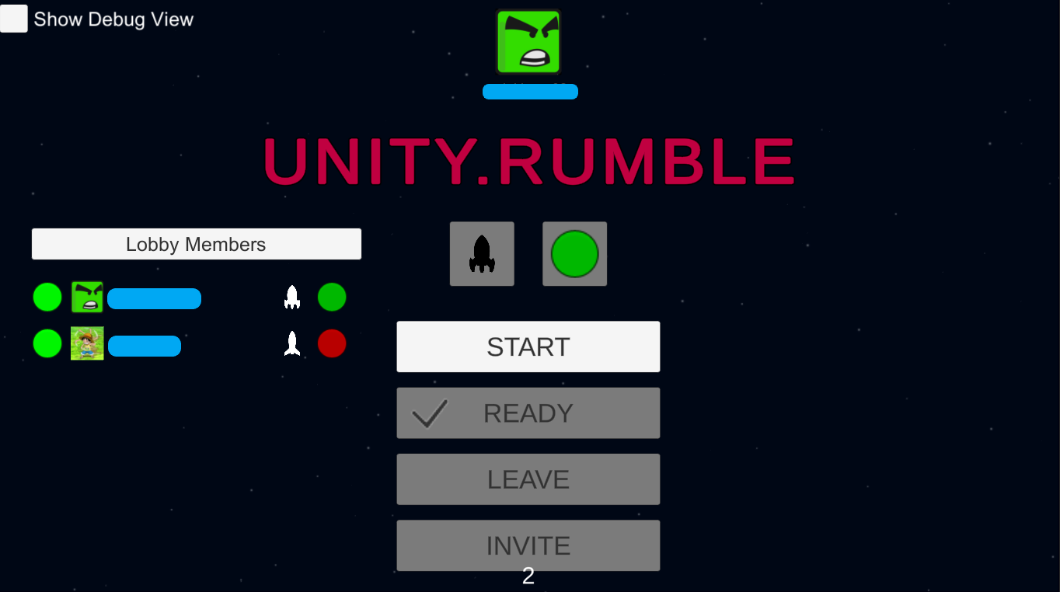

# The Game Play Screen

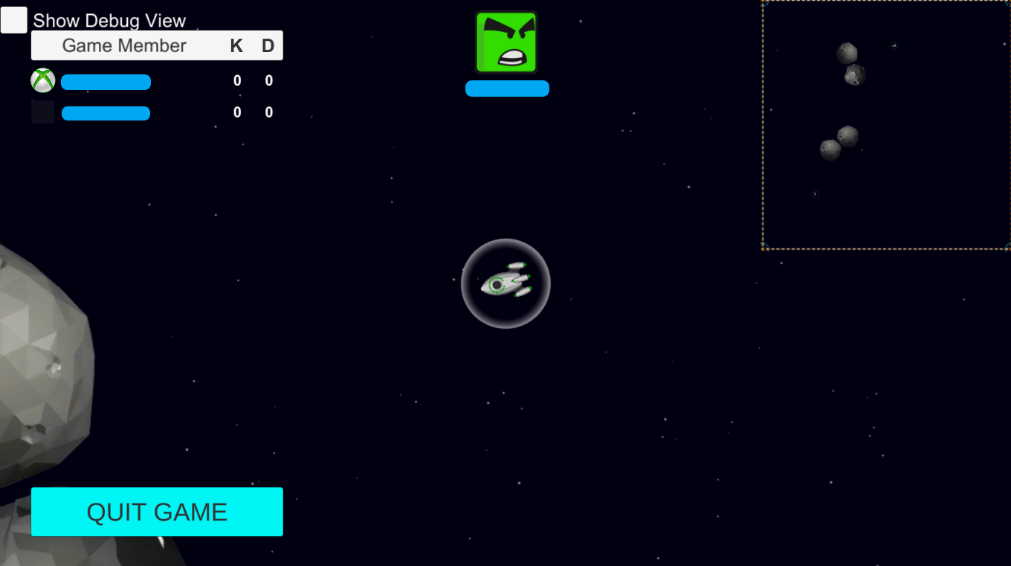

The upper left corner of the Game Play screen shows the current game's player, with username and "kill" and "death" statistics.

The steam icon to the left of the host's name indicates whether it is the owner. If a user clicks the "Quit Game" button to quit the game, he will disappear from other player's player lists. Players can make real-time voice calls after joining the game.

The game ends when a player has a kill score of 5. At this point, the game end screen will pop up, and click the "OK" button to return to the Main Menu screen, as shown below:

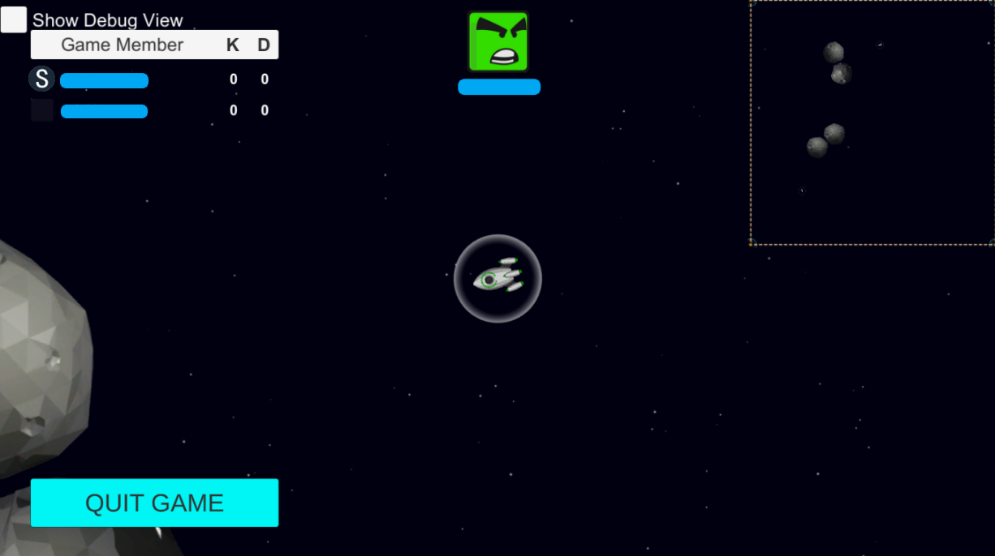

# The Leaderboard Screen

Click the Leaderboard button on the Main Menu screen to open the Leaderboard screen as shown below:

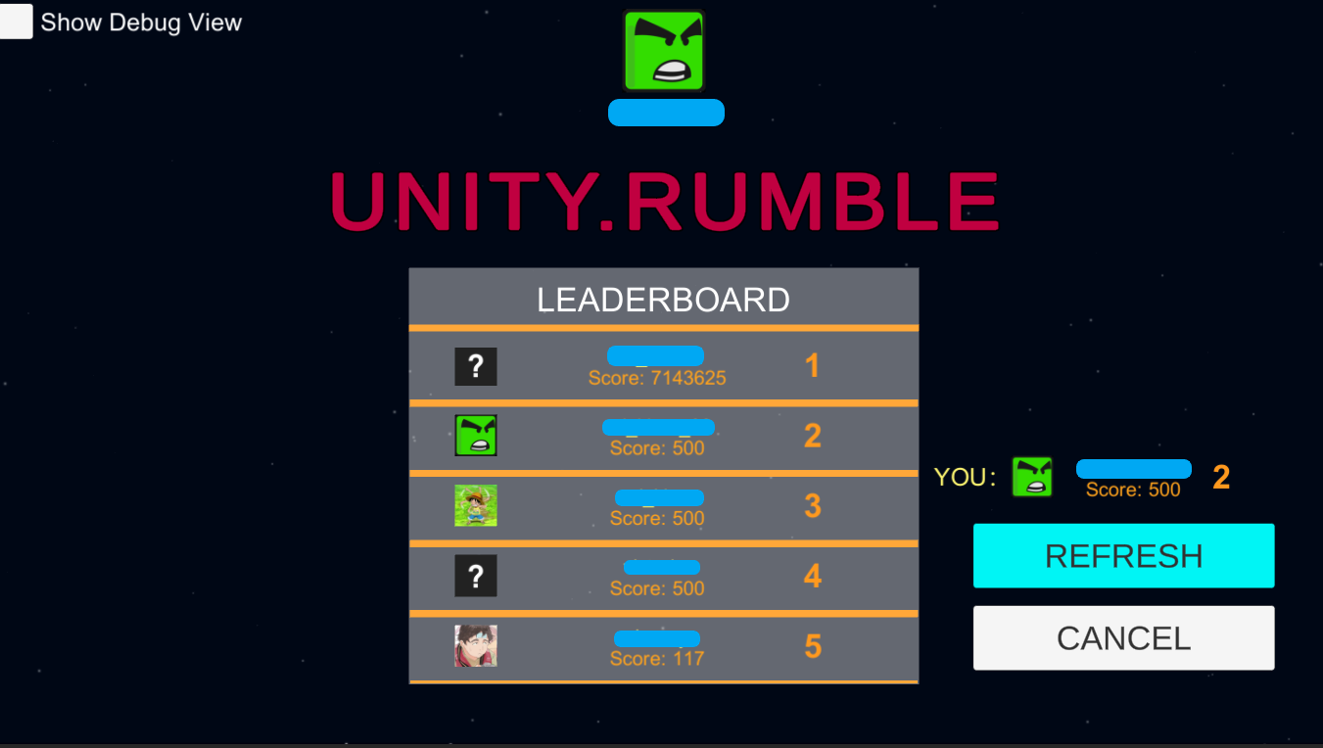

In the Leaderboard Screen, the overall Leaderboard is displayed in the middle position, and its Leaderboard data is displayed in the lower right corner. Click the REFRESH button to REFRESH Leaderboard information, and click the CANCEL button to return to the Main Menu Screen.

# The Profile Screen

Almost all screens display the personal information of steam users, including their profile picture and username, as shown below:

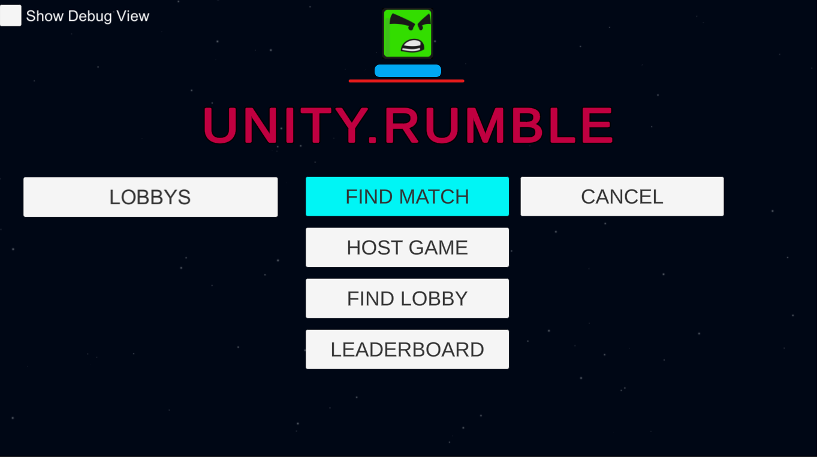

# The Inventory Screen

Display of player inventory information，After running the game, select “Show Debug View” on the game Start screen and click the Start button to start the game. After entering the Main Menu screen, a dialog box will pop up, displaying the player's inventory information, as shown below:

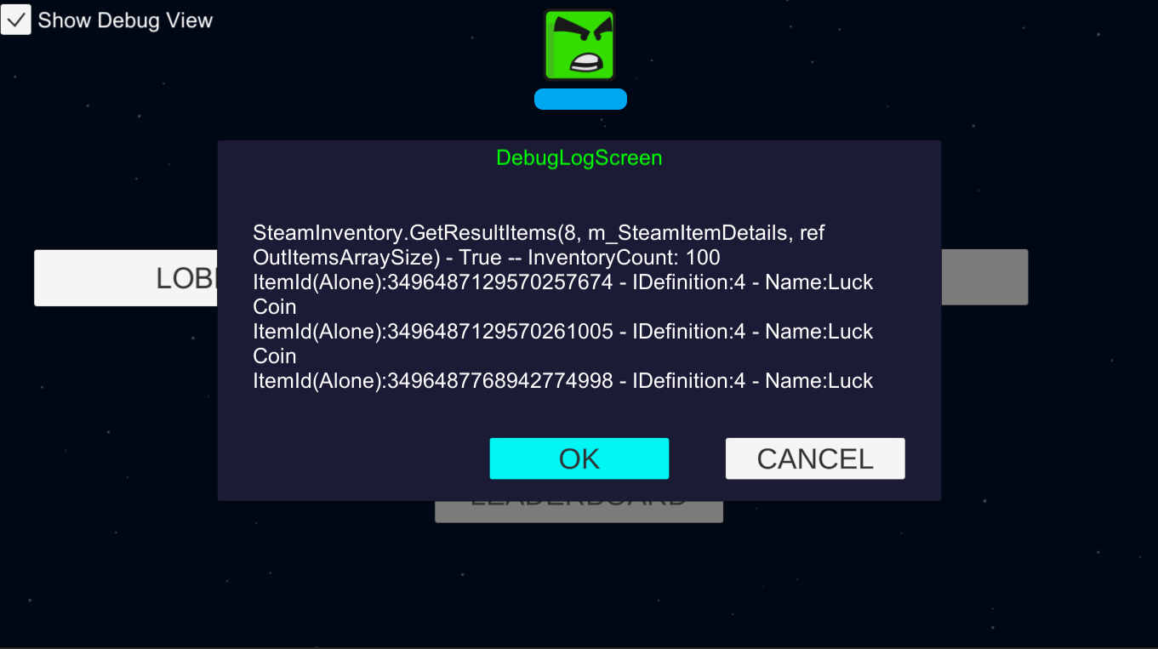

Implementation notes

You can find the sample script in the “Assets/Sample/Scripts" folder, which contains "UI/View"-related code and core logic.

•The script code for the network part of Steam is in Assets\Sample\Scripts\SteamLogic

•Steam's Lobby, Profile, Matching, Achievement, Leaderboard, and Inventory are in Assets\Sample\Scripts

•The script code for voice is in Assets\Sample\Scripts\VoiceChatManager

•To use the Steam plugin, make sure "STEAMWORKS_NET" are defined in Player--> Project Setting -- > Scripting Define Symbols, as shown in the image below:

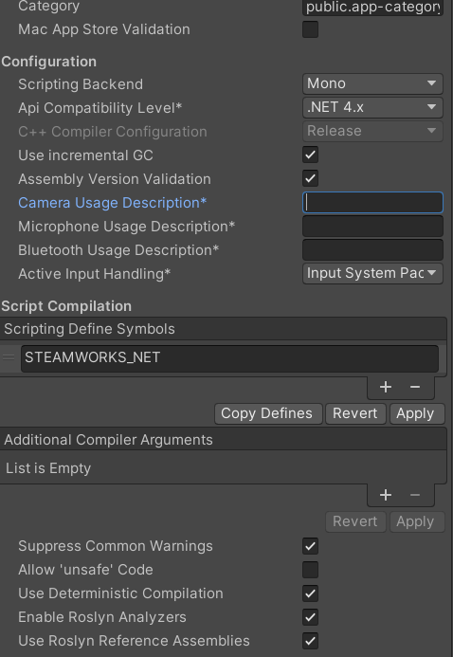

Known issues

This example is based on the latest version of Steamworks.NET at the time of development. Using newer versions of the Steamworks.NET Unity plugin or integrating its different versions may cause incompatibilities with the current code.

Privacy Statement

For more information about Microsoft’s privacy policies in general, see the [Microsoft Privacy Statement – Microsoft privacy](https://privacy.microsoft.com/en-us/privacystatement/).